PENETRATION TESTING REPORT
FOOTPRINTING & NETWORK SCANNING PHASES
W2-PM-FINAL | CYBERSECURITY | NETWORKWALKS

Pentester Name  (Cybersecurity Professional) | Sikhanyiso B. Sibisi
Program/Batch | B083-Networkwalks
Date | 17 September 2026
Modules completed | W2-PM1 (FootP - Multiple Kali Tools)  W2-PM5 (Net. Scanning - Zenmap)
Client/Target | 1. Networkwalks (written permission already secured)  2. My own local LAN Network Lab
Permission secured from client? | Yes
Phases covered | Phase 1: Reconnaissance & Footprinting  Phase 2: Scanning & Network Discovery  Phase 3-5: In Progress

1. Liability Disclaimer
All security testing and related activities described in this report were conducted exclusively on systems and devices that I personally own or for which I had obtained explicit written authorization from the respective owner. No testing was performed against systems or devices outside the authorized scope.
The techniques, findings, tools, and supporting materials presented in this report are provided strictly for educational, research, and authorized security-testing purposes.

2. Introduction
This Week 2 cybersecurity report covers two reconnaissance activities: footprinting the networkwalks.com domain using Kali Linux tools (W2-PM1) and scanning my own local network using Zenmap (W2-PM5). The report documents the commands, results, screenshots, and security relevance of each activity. All testing was performed within an authorized scope for educational and cybersecurity training purposes.

3. Tools Used
The table below lists each tool used in this report and its purpose.
Tool | Purpose
Kali Linux & Windows | Operating systems used for reconnaissance activities
WHOIS | Find domain registration details (owner, dates, name servers).
whatweb | Fingerprint web technologies (server, CMS, plugins, IP).
nslookup | Resolve the domain name to its IP address using DNS.
curl -I | Read the HTTP response headers of the website.
wafw00f | Detect whether a Web Application Firewall protects the site.
dnsrecon | Enumerate all DNS records (NS, MX, SPF, TXT, SRV).
Zenmap (Nmap GUI) | Scan the local subnet to find live hosts, IPs and MAC addresses.
Windows CMD | Local IP and MAC address identification

4. Activities Performed

4.1 Footprinting & Reconnaissance

I performed reconnaissance against the networkwalks.com domain using six Kali Linux tools below.
1. WHOIS
I used WHOIS to retrieve publicly available domain registration information. It helped me identify details such as the domain registrar, registration information, and name servers associated with the domain.

2. WhatWeb
I used WhatWeb to identify the technologies and frameworks used by the website. It helped me detect the CMS, plugins, and other technologies exposed by the web application. In my scan, I identified Bootstrap 7.1, jQuery 3.7.1, WordPress 7.1 and WP Download Manager 3.3.58.

3. Nslookup
I used Nslookup to perform DNS lookups and resolve the domain name to its associated IP address. In my test, networkwalks.com resolved to 192.232.216.135.

4. Curl
I used Curl with the -I option to inspect the HTTP response headers returned by the website. This helped me gather additional information about the web application and identify the exposed WordPress REST API endpoint /wp-json/.

5. Wafw00f
I used Wafw00f to check whether a Web Application Firewall (WAF) was protecting the website. The tool identified ModSecurity (SpiderLabs) as the WAF.

6. DNSRecon
I used DNSRecon to enumerate publicly available DNS records associated with the domain. It helped me identify information such as name servers, mail servers, SPF/TXT records, service records, and other DNS-related details.

4.2 Network Scanning with Zenmap
For the second activity, I used Zenmap to perform network discovery on my local network. The objective was to identify my local IP address and subnet, discover active hosts, identify their IP and MAC addresses, and create a visual network topology.
I first used the Windows ipconfig command to determine my local IP address and LAN subnet. I then entered the identified subnet into Zenmap and selected the Ping Scan option to discover active devices on the network.
The practical results identified four live hosts:
- 10.0.0.1
- 10.0.0.2
- 10.0.0.9
- 10.0.0.10
The scan results also displayed the corresponding MAC addresses for the discovered hosts.
After completing the scan, I opened the Topology section in Zenmap, enabled the legend, and reviewed the visual representation of the discovered network. I then saved the network topology as a PDF, as required by the practical task.

5. Risk Analysis / Impact
Based on the information collected during the footprinting and network scanning activities, I identified the following potential risks.

# | Risk / Finding | Evidence / Observation | Potential Impact | Risk Level
1 | Publicly available | WHOIS provides information and name servers | May provide an external party with information about the domain's registration and DNS infrastructure, which can support further reconnaissance. | ● Low
2 | Web technology information exposed | WhatWeb identified WordPress and WP Download Manager | Revealing the CMS and plugin versions may help an attacker identify technologies that require security monitoring or version-specific research. | ● Medium
3 | Server IP address identifiable | Nslookup resolved the domain to 192.232.216.135 | Identifies the network endpoint associated with the domain and can assist with further infrastructure reconnaissance. | ● Low
4 | HTTP technical information exposed | Curl returned HTTP response headers and exposed /wp-json/ | Server and application information can provide useful details for reconnaissance and attack-surface mapping. | ● Low
5 | WAF technology identifiable | Wafw00f identified ModSecurity (SpiderLabs) | Reveals information about the web application’s security architecture | ● Low
6 | DNS infrastructure information exposed | DNSRecon identified DNS, mail and service-related records | DNS information can help build a broader infrastructure profile | ● Medium
7 | Multiple live hosts visible on local network | Zenmap identified four live hosts in the example network | Unknown or unauthorized devices may potentially be present on a network | ● Medium

Risk level key: ● Critical ● Medium ● Low
The risks above are observations from the footprinting and scanning exercises, not confirmed vulnerabilities.
The practical exercises primarily involved information gathering and host discovery. No exploitation or vulnerability validation was performed as part of these two modules.
Therefore, the presence of information such as a software version, IP address or DNS record does not by itself mean that the system is vulnerable. Further authorized security testing would be required to confirm any actual vulnerability.

6. Recommendations
Based on the observations from these activities, I recommend the following security improvements:
- Review publicly exposed technology information
Organizations should regularly review what information about their web technologies, CMS and plugins is publicly visible and limit unnecessary information disclosure wherever possible.
- Keep software updated
I recommend regularly updating WordPress, WP Download Manager, and other installed components to supported and secure versions. Unused plugins should be removed.
- Review HTTP headers
HTTP response headers should be reviewed to determine whether unnecessary technical information is being exposed.
- Review DNS records regularly
DNS records should be checked periodically to ensure that only required information and services are publicly exposed.
- Properly configure and monitor the WAF
Keep the WAF (ModSecurity) enabled and tuned, since it already blocks naive attacks.
- Perform regular internal network discovery
Organizations should periodically scan their own networks to identify active devices.
- Investigate unknown devices
Any unexpected device discovered during network scanning should be investigated and verified.
- Maintain network documentation
Network topology and device information should be documented and updated regularly.
- Perform security testing with authorization
I recommend conducting authorized vulnerability assessments and network reviews periodically to identify newly exposed services, outdated software, configuration issues, and other security weaknesses.

7. Conclusion
During Week 2 of my Cybersecurity & Ethical Hacking internship, I completed practical exercises covering footprinting, reconnaissance, and network scanning.
I used six Kali Linux tools—WHOIS, WhatWeb, Nslookup, Curl, Wafw00f, and DNSRecon—to gather and analyze information about a domain. I also used Zenmap to examine my local network, identify active hosts, collect IP and MAC address information, and create a network topology.
These exercises helped me understand the importance of information gathering in cybersecurity. I learned that significant information about a system or network can be identified through publicly available data and network responses before any exploitation is attempted.
I also learned the importance of documenting technical findings clearly, including the activity performed, observations made, potential risks, and recommended security measures. Most importantly, I learned that reconnaissance and scanning activities must always be performed within an authorized scope. All activities in this report were conducted as part of my assigned educational cybersecurity lab.

8. Evidences Collected

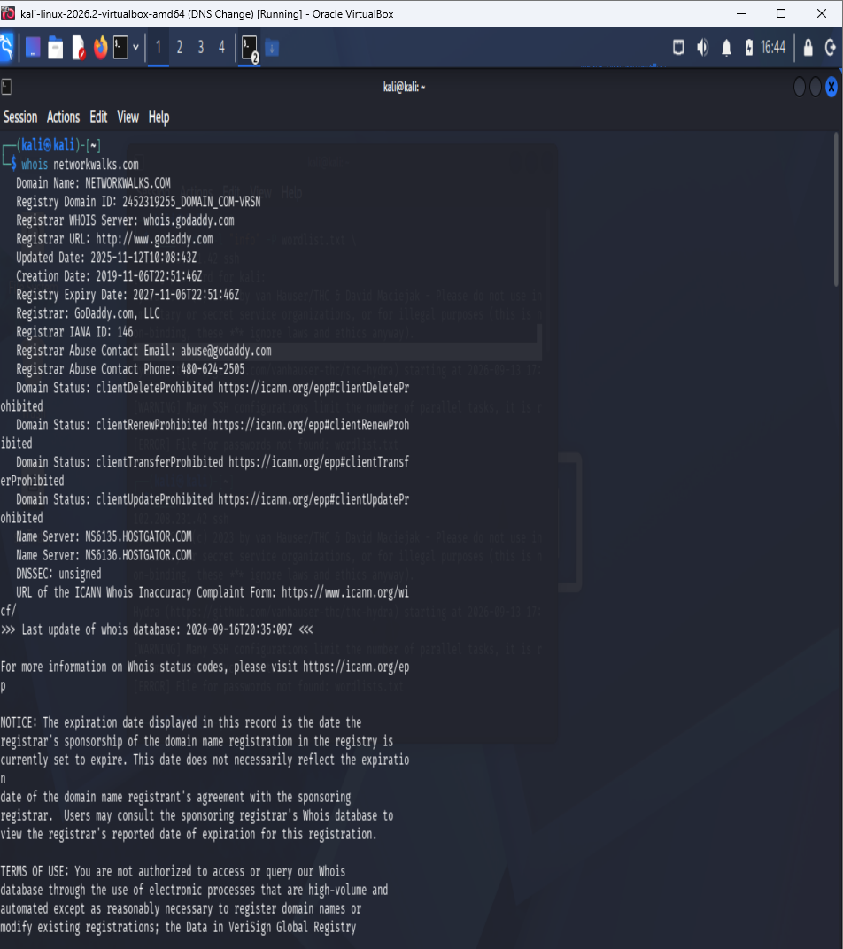

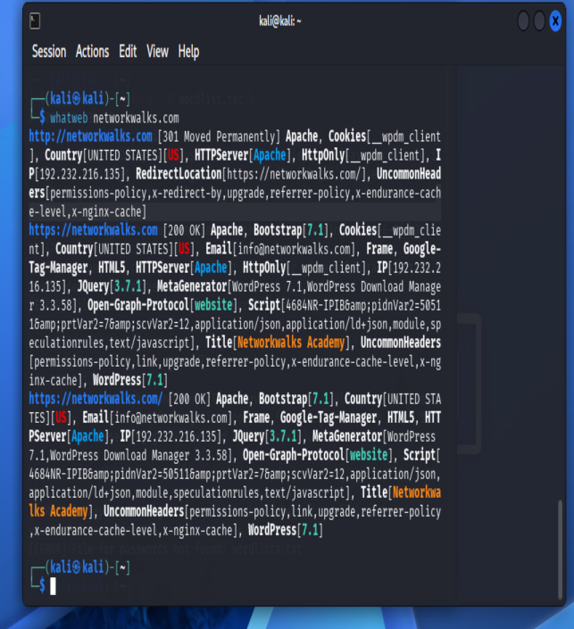

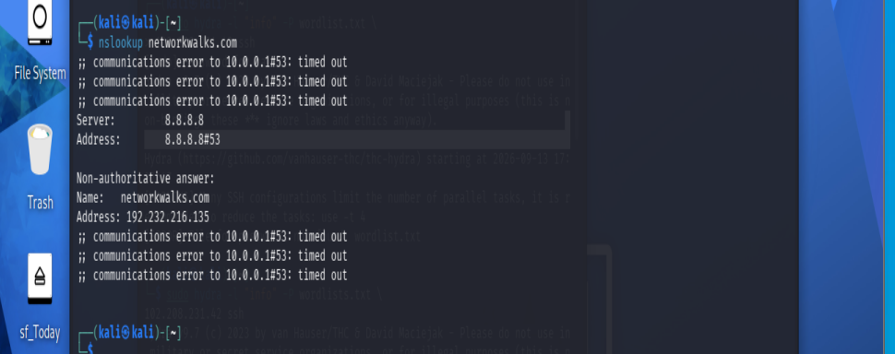

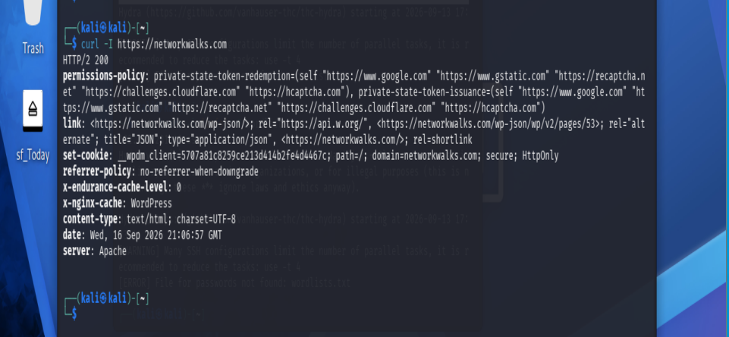
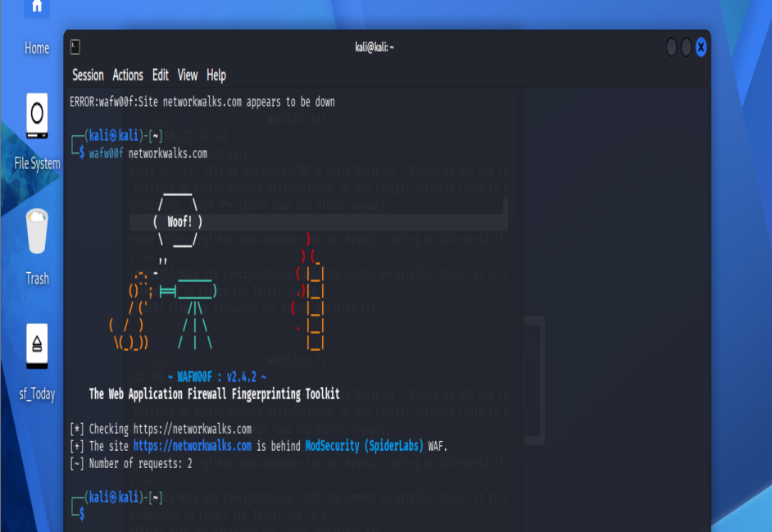

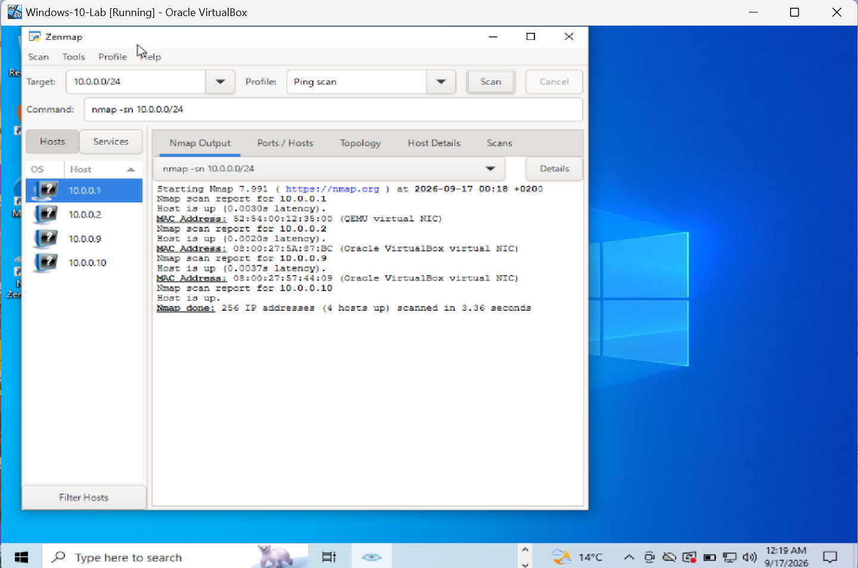
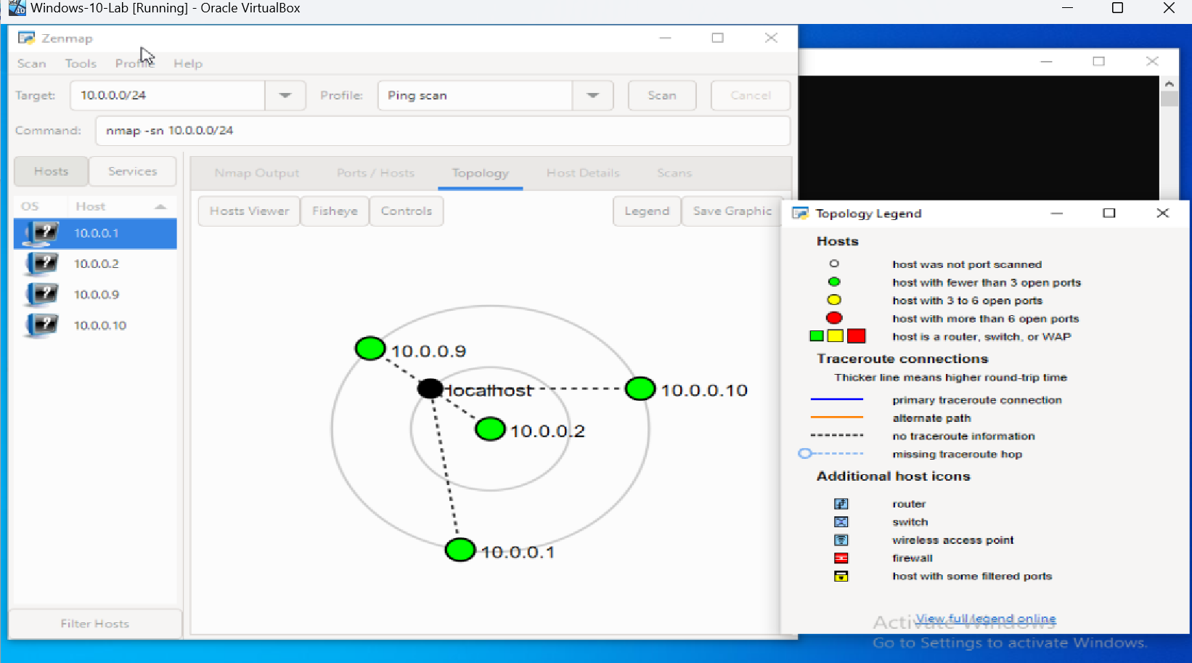

👤 Author
Sikhanyiso B. Sibisi
Cybersecurity Professional B083
LinkedIn: https://za.linkedin.com/in/sikhanyiso-b-s-a28a0b13a

📌 Project Information
Program Name: Cybersecurity program at Networkwalks | Week: 02 | Repository: GitHub

